Analysis of Functional and Sensory Properties of Fermented Mushroom Snacks
– Dr. Kavya Venugopal

This study employed a combined statistical and machine learning framework to evaluate the effects of species, pre-treatment, and probiotic inoculation on the functional and sensory properties of fermented mushroom snacks. A Random Forest regression model was selected due to its ability to capture non-linear relationships and interactions between categorical processing factors and multiple response variables without requiring strict parametric assumptions.
The analytical workflow consisted of
- data preprocessing, including encoding of categorical variables and removal of incomplete observations, followed by
- model development to quantify the relative importance of experimental factors.
- one-way analysis of variance (ANOVA) was conducted within each species to assess the statistical significance of pre-treatment effects on antioxidant activity, vitamin content, and sensory properties
- an optimization step was performed to identify processing conditions that maximized individual response variables, enabling the evaluation of trade-offs between functional and sensory attributes.

1. Data Description
The dataset comprised 204 observations representing fermented mushroom samples derived from three species: Agaricus bisporus, Imleria badia, and Lactarius deliciosus. Each sample was characterized by two experimental factors, namely pre-treatment (including water blanching, microwave blanching, and no pre-treatment) and probiotic inoculation (Lactobacillus acidophilus, Lactiplantibacillus plantarum, or no inoculation). The measured response variables included antioxidant activity (ABTS, DPPH, FRAP), total phenolic content (TPC), vitamin content (B1 and B2), β-glucan content, texture, and sensory score. Following data preprocessing, 24 samples containing missing values were removed, resulting in a final dataset of 180 observations used for s ubsequent statistical and machine learning analyses.

2. Data Processing and Analytical Approach
2.1 Data preprocessing
Categorical variables, including species, pre-treatment, and probiotic inoculation, were encoded to enable machine learning analysis. A combined sensory index was calculated as the sum of texture and sensory score to represent overall product acceptability. All incomplete observations were removed to ensure consistency and reliability of the dataset.

2.2 Machine learning analysis
A Random Forest regression model was applied to evaluate the relative importance of experimental factors in determining functional and sensory properties. The model demonstrated satisfactory predictive performance (R² ≈ 0.70). Feature importance analysis revealed that species accounted for 61.5% of the variability, followed by pre-treatment (29.3%) and probiotic inoculation (9.1%).

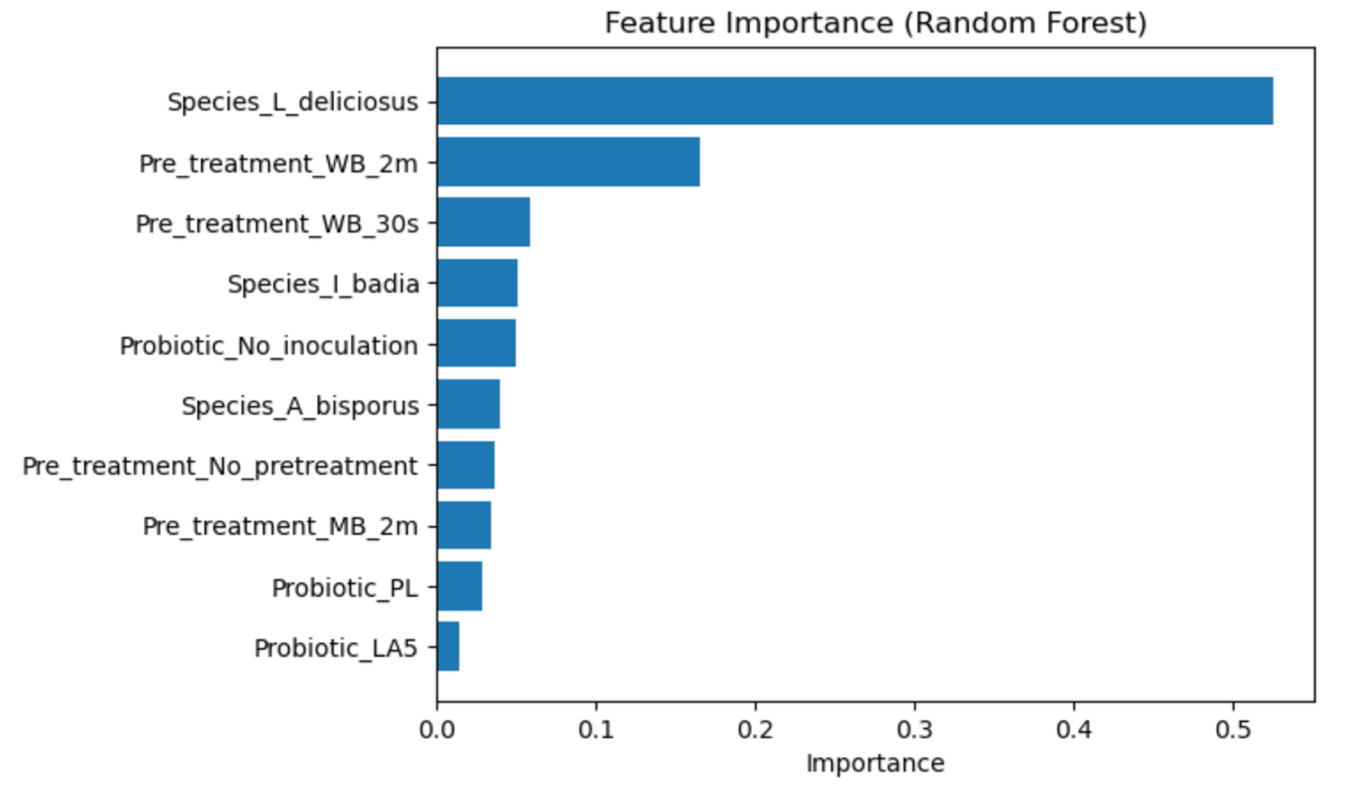

2.3 Statistical analysis
One-way analysis of variance (ANOVA) was conducted within each species to assess the effect of pre-treatment on antioxidant activity, vitamin content, and sensory properties. Statistical significance was determined at p < 0.05.

2.4 Optimization analysis
For each species, the processing conditions yielding the highest values were identified for antioxidant activity, vitamin B1 and B2, and sensory quality. This allowed the identification of optimal conditions and comparison across different functional targets.

3. Results and Discussion
3.1 Antioxidant Activity
- Pre-treatment exerted a significant effect on antioxidant activity, with responses varying across species and assay type.
- In A. bisporus, all antioxidant assays were significantly affected (p < 0.001), indicating strong sensitivity to processing conditions.
- In I. badia, significant differences were observed for ABTS and DPPH, while FRAP remained unaffected.
- In L. deliciosus, ABTS and FRAP showed significant variation, whereas DPPH did not.
- These results demonstrate that antioxidant responses are both species-dependent and mechanism-specific, reflecting differences in radical scavenging and reducing capacity.

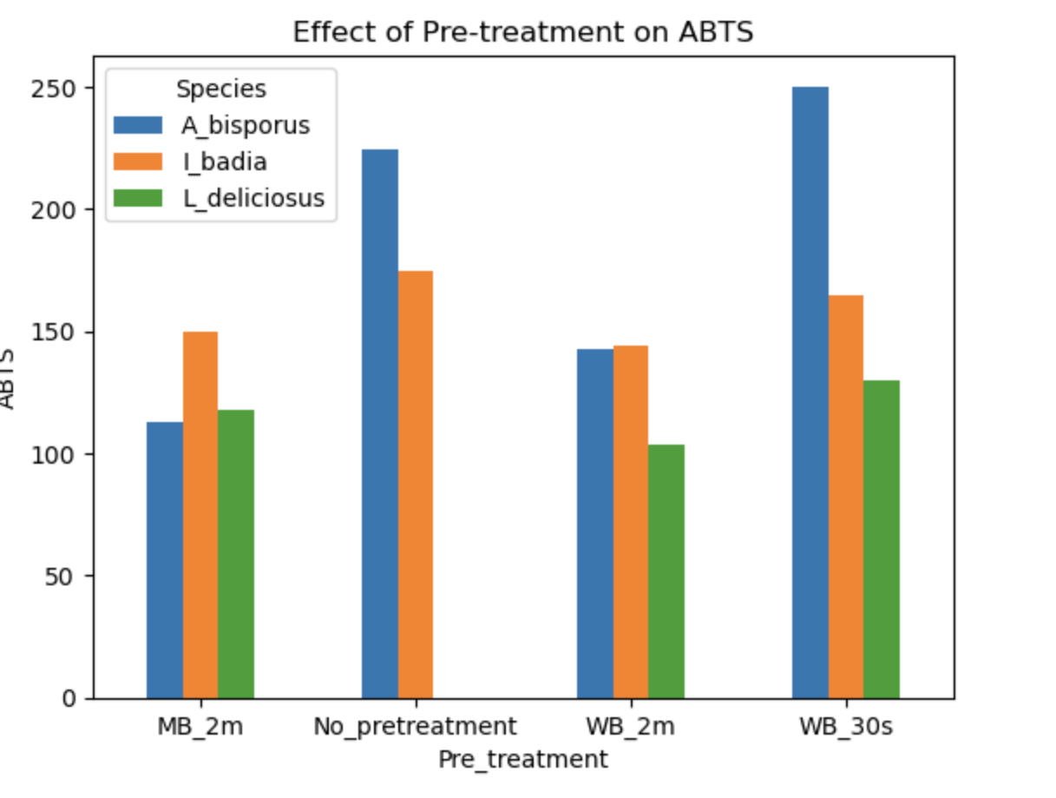

3.2 Vitamin Content
- Vitamin content exhibited a clear species-dependent response to processing conditions.
- Vitamin B₂ showed greater sensitivity to pre-treatment than vitamin B₁ across all species.
- L. deliciosus displayed the highest vitamin concentrations, particularly for B₁, while A. bisporus showed a strong response for B₂ and moderate variation for B1.
- In I. badia, both vitamins were moderately affected by processing. These findings indicate that riboflavin is generally more responsive to processing-induced changes than thiamine.

3.3 Sensory Properties
- Sensory quality, expressed as a combined index of texture and acceptability, showed distinct species-specific behavior.
- No significant effect of pre-treatment was observed in A. bisporus (p = 0.139) or L. deliciosus (p = 0.726), indicating stability of sensory properties despite processing variations.
- In contrast, I. badia exhibited a highly significant response (p < 0.001), suggesting that processing conditions strongly influence its sensory characteristics.
- These results indicate that sensory perception is less sensitive to compositional changes than chemical parameters, except in specific species.

3.4 Optimization and Trade-offs
Comparison of optimal processing conditions revealed that antioxidant activity, vitamin content, and sensory quality were maximized under different treatments. In most cases, the conditions yielding the highest functional properties did not coincide with those providing optimal sensory quality. This demonstrates the presence of trade-offs and indicates that the system represents a multi-objective optimization problem, where processing conditions must be selected based on the intended product functionality.

3.5 Machine Learning Validation
The machine learning results support the statistical findings by confirming that species is the dominant factor influencing all measured properties. The substantial contribution of pre-treatment further highlights the importance of processing conditions, while the relatively minor role of probiotic inoculation suggests limited impact under the studied conditions. The agreement between statistical and machine learning approaches strengthens the robustness of the conclusions.

4. Conclusions
- Species was identified as the primary determinant of both functional and sensory properties of fermented mushroom snacks, with pre-treatment exerting a secondary but significant influence.
- Probiotic inoculation contributed comparatively little to the observed variability. Antioxidant responses were found to be mechanism-dependent and assay-specific, while vitamin B₂ exhibited greater sensitivity to processing than vitamin B₁.
- Sensory properties did not consistently reflect changes in chemical composition, indicating a disconnect between functional enhancement and consumer perception.
- Overall, no universal optimal processing condition was identified, and optimization must be tailored to specific target attributes.
________________________________________________________________________

